**User Guide - Sudoku Application**

**Abel Tabor, Thomas Edwards, Brian Jefferson**

**CMSC 495**

**Section 7384**

**Group 5**

**5/4/2022**

**Professor Dao**

**Revision History**

| **Name** | **Date** | **Description** |
| --- | --- | --- |
| Brian Jefferson | 4/30/2022 | Updated User Guide |
| Brian Jefferson | 5/2/2022 | Modified How to Operate section |
| Brian Jefferson | 5/7/2022 | Modified Final Project User Guide and formatting |

**User’s Guide**

Sudoku is a logic based placement puzzle, the origin of this game comes from Japan. A puzzle at which point players enter the numbers individual to nine into a 9 x 9 grid, every number performs previously in each level line, upright line, and square. This puzzle is timed and the faster you are able to complete the sudoku the higher the score. Since the Sudoku is partially completed there is only one correct solution.

This application is intended for use by students, novice, mathematicians and anyone interested in playing the sudoku, no age limit. As there is no prize given for the sudoku on this application, game scores are posted to the leaderboard where they can be viewed for comparison. The application is meant to resemble the paper version of sudoku in a digital version. This application is split into two parts, one where the user starts a new game, and another which allows a user to see the leaderboard and view where they stack on it.

**Requirements**

Windows:

* Windows 7 or later
* Penguin 4 processor or later

IDE:

* Not Required

DATABASE:

* Local

NETWORK:

* Internet Access Not Required

**How To Install**

To run this application you must download the Microsoft .Net Framework installed. Users must have the released “SpeedSudoku.exe” file from the deliverables. GitHub repository (https://github.com/ThomasJE85/CMSC-495-Group-5.git)> ”Releases” > “Releasev1.0” > “Release.v1.0.zip”) Download the zip file, the folder is required (Windows required) > *Run “SpeedSudoku.exe*.

**How To Operate**

**game welcome screen**

1. Open Executable file

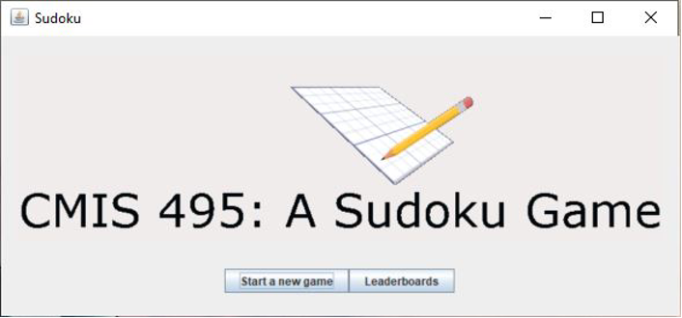

**empty game board**

2. Select “Start a New Game”

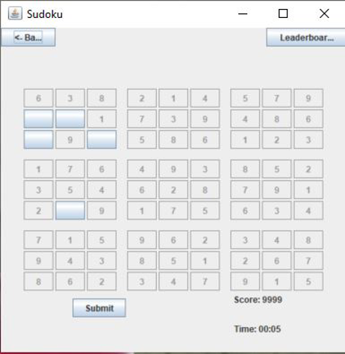

**Entering in a valid username**

3. Make game input to the game board and click Submit

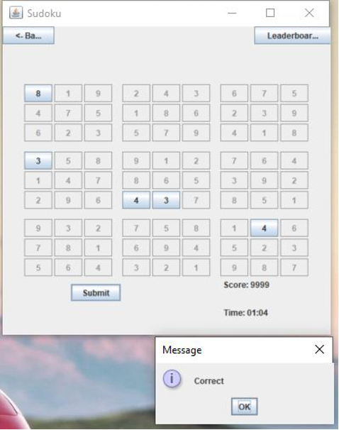

**Make your game inputs onto the board**

4. Enter a Username to play, and click OK, select OK to leaderboard submission and then click Back

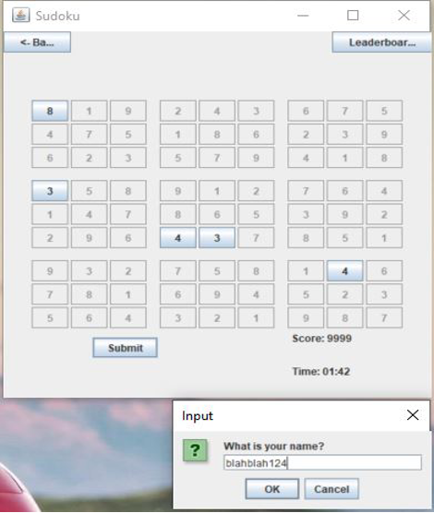

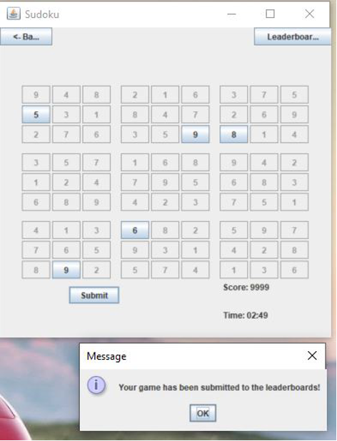

5. Select Leaderboards



**1 complete game leaderboard**

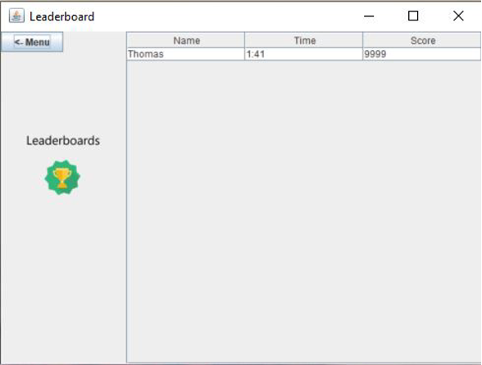

**Handling Error Messages**

1. ***Opening Application on Windows**

***Warning about protecting Windows***

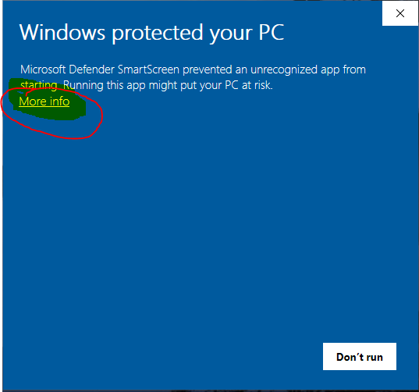

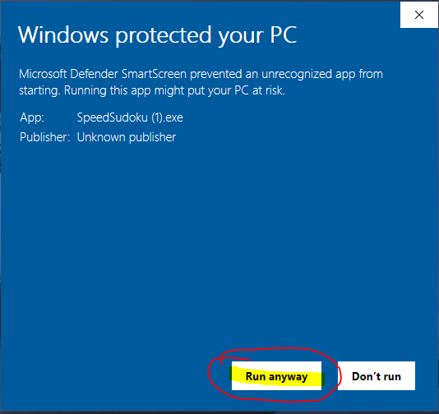

***Select “More Info”, then select “Run Anyway” to run the application

1. ***Invalid name attempt**

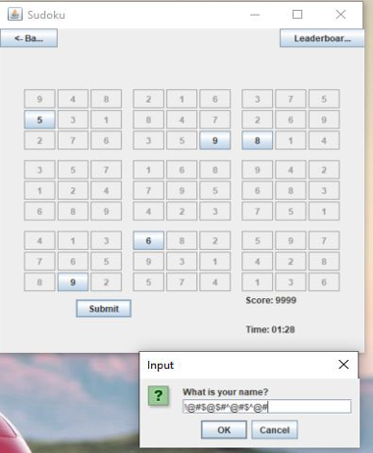

**** Notification for invalid name entry****

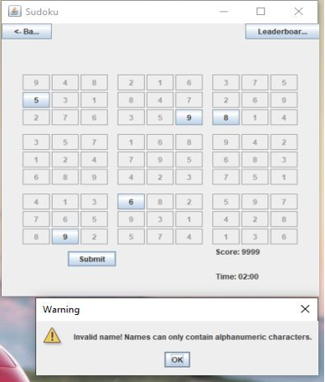

** Inputting a valid name with no special characters will resolve this**

1. **Incomplete submission attempt**

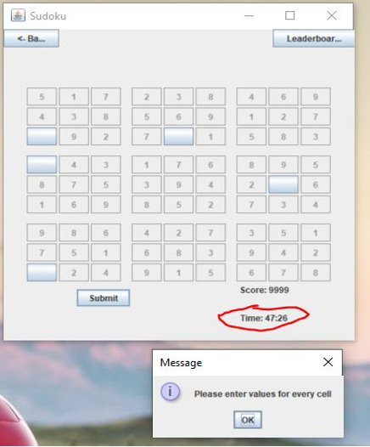

**You must make some type of attempt at the in order to select submit.**

****Leave in-progress****

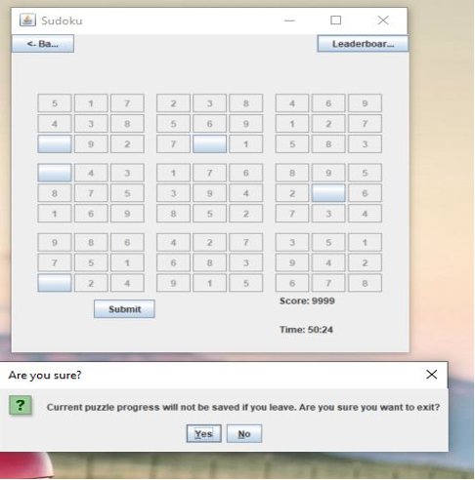

**You will have to click submit first if you want your gameplay to be logged on the leaderboard**

1. **duplicate entry attempt for submission**

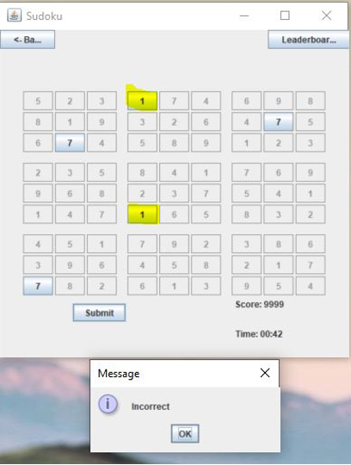

**Can not use the same digit twice**

1. **invalid submission to leaderboard’s to database**



**Start a new game, and resubmit **